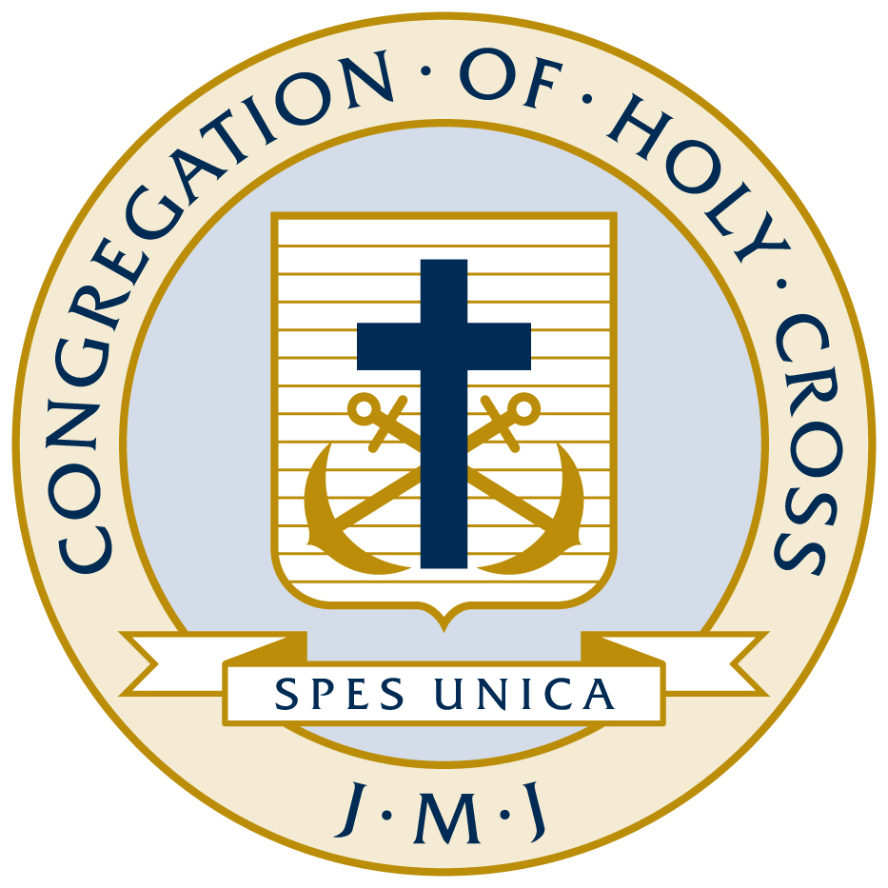
Congregation of Holy Cross, United States Province, Inc.
Job Description

Job Title: Nursing Assistant
Department: Holy Cross House
Reports To: Nurses on Duty, in conjunction with the Director of Nursing
FLSA Status: Non-Exempt
Category: Full-Time, Part-Time, Casual
Schedule: 1st, 2nd, 3rd Shifts
Last Revision:
Reviewed: January 2018

Summary
The general purpose of this position is to provide medical, nutritional, emotional, and/or spiritual care to the residents of the Holy Cross House, and to interact with residents in a loving and caring manner to ease the turmoil of retirement, loss of privacy and independence. Holy Cross House is a religious community offering medical care to members of Congregation of Holy Cross. Holy Cross House is a non- licensed operation, providing assisted living and skilled care without the support of governmental aid.

Essential Duties and Responsibilities
(Includes but not limited to the following. Other duties may be assigned.)
- Assist residents with activities of daily living as assigned
- Perform necessary cleaning and disinfecting duties as pertains to medical and personal equipment; hearing aids, urinary drainage (UD) bags, urinals, walkers, and wheelchairs
- Report any change in resident condition or behavior to the Shift Nurse and/or Director of Nursing
- Provide residents with assistance in all House activities
- Assist residents with correspondence, phone calls, and other social interactions
- Assist residents in repositioning or transferring from/to beds, chair, or walker using medical equipment
- Document resident care by recording nutrition intake, voids, and bowel movements as directed
- Conduct range of motion exercises with residents as directed
- Maintain resident rooms by making beds, changing linens, and gathering/distributing laundry
- Ensure cleanliness of all tubs, showers, wash basins, emesis basins, linens, tables, countertops, closets, and storage areas
- Stock and maintain supplies in storage areas
- Ensure shift report is communicated and received
- Round with oncoming/outgoing shifts to ensure communication of resident care
- Maintain the confidentiality of all resident care information, and ensure that all residents be treated with kindness, dignity, and respect
- Ensure residents have clean garments for special occasions and masses
- Provide post mortem care to residents
- Sort clothing and personal items of deceased residents for retention or donation

Qualifications
To perform this job successfully, an individual must be able to perform each essential duty satisfactorily. The requirements listed below are representative of the knowledge, skill, and/or ability required. Reasonable accommodations may be made to enable individuals with disabilities to perform the essential functions.

Education and/or Experience
A High School Diploma or equivalent and one (1) to three (3) years of relevant experience is required. Certified Nurse Assistant (CNA) training is preferred. Experience with geriatric populations and psychosocial behavioral issues is strongly preferred.

Computer/Office Equipment Skills
To perform this job successfully, an individual must have experience using equipment commonly used in patient care such as walkers, sliding boards, lateral scoots, tubs, mechanical lifts, and patient call light systems. A familiarity with basic office equipment such as copiers, fax machines, voicemail systems, multi-line telephones is required.

Other Qualifications, Skills and Abilities
This position requires basic oral and written communication skills, good interpersonal communication skills, and the ability to work with a high degree of accuracy and confidentiality. This position requires the ability to work independently, make routine decisions, follow basic instructions, work well alone and as part of a team, multi-task and recognize and set priorities. This position requires a professional appearance and a caring attitude. The ability to foster collaborative relationships and to work with people from diverse cultural backgrounds is expected. The ability to be respectful of the religious beliefs of the Congregation is required. The ability to tolerate interruptions, work under pressure, handle a crisis calmly, and handle all problems or concerns professionally is essential. This position requires the ability to follow the direction of on-duty nurses, whom work in conjunction with and under the authority of the Director of Nursing.

Valid CPR certification is required.

Physical Demands
The physical demands described here are representative of those that must be met by an employee to successfully perform the essential functions of this job. Reasonable accommodations may be made to enable individuals with disabilities to perform the essential functions.

While performing the duties of this job, the employee is regularly required to stand, walk, and to use hands to finger, handle, or feel and talk or hear. The employee is frequently required to reach with hands and arms, sit, stoop, twist, crouch, and bend. The employee is occasionally required to kneel or crawl. The employee must frequently lift and/or move up to 25 pounds and occasionally lift and/or move up to 100 pounds with the assistance of lifts and other equipment. Specific vision abilities required by this job include close vision, distance vision, color vision, peripheral vision, depth perception, and the ability to adjust and focus.

Work Environment
The work environment characteristics described here are representative of those an employee encounters while performing the essential functions of this job. Reasonable accommodations may be made to enable individuals with disabilities to perform the essential functions.

The work environment consists of working in conjunction with the Congregation and, at times, family members, to provide direct care for residents that are elderly and suffering from various stages of illness. As a result, the work environment is subject to being stressful and emotionally sensitive, and may result in unfavorable workplace interactions.

This position is exposed to various infectious wastes, diseases, conditions, and hazardous chemicals.

While performing the duties of this Job, the employee is occasionally exposed to outside weather conditions. The noise level in the work environment is usually moderate.

